MEMORIAL BENCH REQUEST FORM

Contact Person_________________________________________________
Street Address__________________________________________________
City, State, Zip__________________________________________________
Phone #_____________________________
Email Address__________________________________________________

MEMORIAL PLAQUE: 4 lines

____________________________________________________________________
____________________________________________________________________
____________________________________________________________________
____________________________________________________________________ PARK IN WHICH DONATION IS TO BE PLACED:
___ Baker Street Playground | Dumor 140-60#
___ Town Wharf | Dumor 140-60#
___ Jamiel Park | Dumor 140-60*
___ Baltimore Ave. Playground | Dumor 140-60*
___ Homestead Ave. Playground | Dumor 140-60*
___ Burr’s Hill Park – Hill side | Dumor 105-80PL+
___ Burr’s Hill Park – Street side | Dumor 141-60*
___ Warren Recreation Park | Dumor 11-60PL+
___ Dog Park | Dumor 140-60*
___ Warren Town Beach – Wall Side | Dumor 140-60*
___ East Warren Bike Path | Dumor 140-60*
___ Warren Town Beach – long bench | Dumor 105-80PL+
___ Veteran’s Field  ___ Community Garden | Dumor 140-60*  Dumor Choices
# Black * Deep Red + Grey Plastic

COST: _____________ Check #____________ Payment Date____________

Date Ordered: ___________ Date Installed: ___________

Donor’s Signature _____________________________________Date____________

Parks & Rec. Dir. approval: ____________________________Date______________
MEMORIAL BENCH PROGRAM OVERVIEW

The Town of Warren Parks & Recreation Department offers a memorial Bench Program for those that wish to contribute to the beauty of the parks by purchasing a bench to be installed in someone’s honor or memory.

Memorial benches provide another option to honor or remember a loved one, as well as offer respite to park visitors to help them enjoy their surroundings. Benches may be installed at any time, weather permitting. Donors will be notified once the bench and marker have been installed. The Town cannot guarantee a specific installation date. All benches will be installed by the Warren Department of Public Works. Donors are not permitted to add additional plantings, flowers or decorations to the memorial’s area.

LOCATION:
The Parks & Recreation Department presently has (14) locations throughout the town; Town Beach (park side), Burr’s Hill Park (top of the hill), Burr’s Hill Park (street side), Baker Street Playground, Baltimore Ave Playground, Jamiel Park, Homestead Park Playground, Dog Park, Veteran’s Field, Warren Recreation Park, Warren Athletic fields (dug outs), Town Wharf, and East Warren Bike Path. The style of bench has been selected by the Parks & Recreation Department based on the location history and consistency with the landscaping.

COMMEMORATIVE PLAQUE:
Each donation will be recognized by a 2” x 10” cast plaque in honor, in memory, or other suitable language approved by the Parks & Recreation Department. The plaque can include verbiage of up to 4 lines of approximately 46 characters and spaces per line. All verbiage will be reviewed and approved by the donor and Parks & Recreation Department.

PURCHASE AND INSTALLATION:
A Memorial Bench Request Form must be filled out. Once it has been determined that the requested location is available, the Parks & Recreation Department will communicate directly with the bench supplier to confirm cost, including shipping. If the donor agrees with the price quote provided, the Parks & Recreation Department will move forward and order the Memorial Bench once a check, made out to the Town of Warren is received.

Once delivery is made the Parks & Recreation Director will work with the Warren Department of Public Works to schedule the installation at the site. Donor will then be contacted to confirm and complete the process.
BENCH OPTIONS:
2026 PRICING

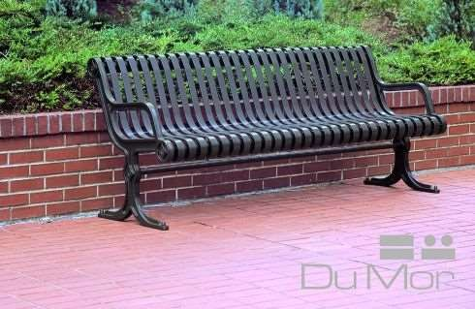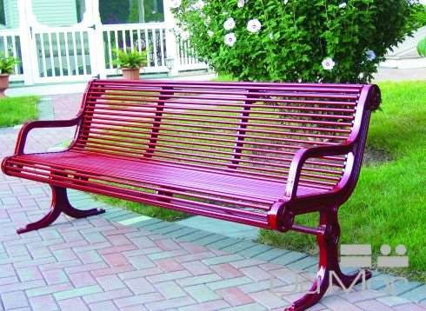

Dumor 140-60 ($2555) Dumor 141-60 ($2983)
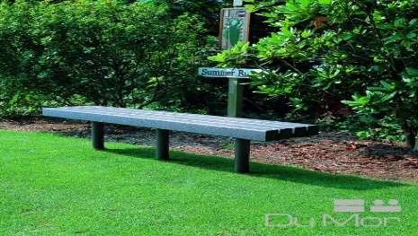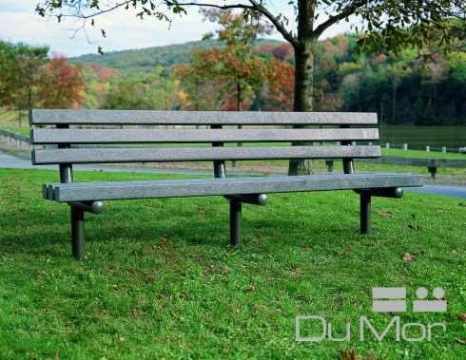

Dumor 105-80P ($1991) Dumor 11-60PL ($1973)

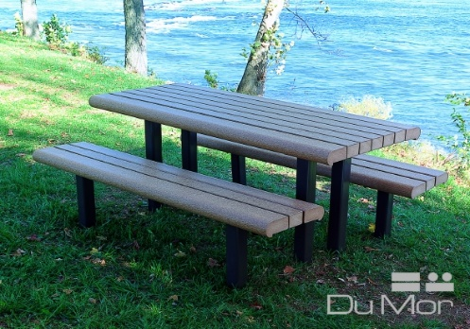

Dumor 100-60PL ($3639) Dumor 100-68 1PL: ADA ($4178)


Town of Warren

Warren Park & Recreation
Department
790 Main Street
Warren RI 02885
Recreation Director Tara Thibaudeau

2026
TOWN OF WARREN
MEMORIAL BENCH
& PICNIC TABLE
PROGRAM

Updated pricing January 2026

warrenrecreation@gmail.com (401) 824-4623

